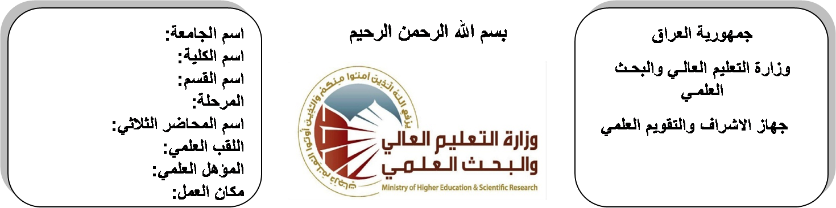

**Republic of Iraq**

**Ministry of Higher Education**

**& Scientific Research**

**University: Diyala University**

**College: College of Engineering**

**Department: Electronic Engineering**

**Stage: first**

**Lecturer name:sawsan abdulmunem**

**Qualification: M.Sc**

**Place of work: Electronic Dept.**

**(( Annual teaching plan form))**

|  |  |  |  |  |
| --- | --- | --- | --- | --- |
| **Lecturer Name** | **Sawsan Abdulmunem** | | | |
| **Email** | **Sawsan.munem@yahoo.com** | | | |
| **Subject** | English | | | |
| **Aims** | **The aim of this subject is to make the students ready to undestand and comprehend the scientific theories and their applications related to their field of the study.** | | | |
| **Textbooks** | Shams EL-Dean, E.J. (1985) A Course in English For Engineering and Scientific Students. | | | |
| **Additional Textbooks** | **1-Swan, M & Walter, C. (1997) How English works .Oxford: Oxford University Press.**  **2-Alexander, L.G. (1988) Longman English Grammar .Longman: Longman Group Limited.**  **3-Philips,D.(2001) Longman Complete Course for the TOEFL-Test Longman: Longman Inc.** | | | |
| **Assessments** | **First Semester** | **Second Semester** | **Laboratory** | **Final Exam** |
| 20% | 20% |  | 60% |
| **Notes** |  | | | |

**Schedule Weekly Lessons - First Semester**

|  |  |  |  |  |
| --- | --- | --- | --- | --- |
| **Week** | **Date** | **Lectures** | **Lab. Experments** | **Notes** |
| 1 | **29/9/** | Parts of Speech. |  |  |
| 2 | **5/10/** | Parts of Speech. |  |  |
| 3 | **12/10/** | Parts of Speech. |  |  |
| 4 | **19/10/** | Reading of Numerals Simple Equation |  |  |
| 5 | **26/10/** | Reading of Numerals Simple Equation |  |  |
| 6 | **2/11/** | Reading of Numerals Simple Equation |  |  |
| 7 | **9/11/** | Exercises |  |  |
| 8 | **16/11/** | Exercises |  |  |
| 9 | **23/11/** | Exercises |  |  |
| 10 | **30/11/** | Exercises |  |  |
| 11 | **7/12/** | Transformers |  |  |
| 12 | **14/12/** | Exercises |  |  |
| 13 | **21/12/** | Electric Motors |  |  |
| 14 | **28/12/** | Exercises |  |  |
| 15 | **4/1/** | Computers |  |  |
| 16 | **11/1/** | Exercises |  |  |
| Half Year holiday | 15/1/ to  1/2/ |  |  |  |

**Lecturer Signature Head of Dept. Signature Dean Signature**

**Schedule Weekly Lessons - Second Semester**

|  |  |  |  |  |
| --- | --- | --- | --- | --- |
| **Week** | **Date** | **Lectures** | **Lab. Experments** | **Notes** |
| 1 | **15/2/** | Exercises |  |  |
| 2 | **22/2/** | The Present Tense |  |  |
| 3 | **1/3/** | The Present Tense |  |  |
| 4 | **8/3/** | The Passive Tense |  |  |
| 5 | **15/3/** | The Passive Tense |  |  |
| 6 | **22/3/** | Make +Name (or pronoun ) + Infinitive |  |  |
| 7 | **29/3/** | Make +Name (or pronoun ) + Infinitive |  |  |
| 8 | **5/4/** | Verb Followed by–ing Form |  |  |
| 9 | **12/4/** | Verb Followed by–ing Form |  |  |
| 10 | **19/4/** | The Position of Tithe Adverbs |  |  |
| 11 | **26/4/** | The Position of Tithe Adverbs |  |  |
| 12 | **3/5/** | The Position of The Adjectives |  |  |
| 13 | **10/5/** | The Position of The Adjectives |  |  |
| 14 | **17/5/** | Some Prefixed Used in Scientific English |  |  |
| 15 | **24/5/** | Some Prefixed Used in Scientific English |  |  |
| 16 | **1/6/** | Questions. |  |  |

**Lecturer Signature Head of Dept. Signature Dean Signature**